|  |  |
| --- | --- |
|  | **K. K. Wagh Polytechnic, Nashik.**  HirabaiHaridasVidyanagari, Amrutdham, Panchavati,Nashik-422003  **Department of Computer Technology** |

**Micro-Project Report**

Institute Code: 0078

Academic Year: 2023-24 Program: Computer Technology

Course: Web Based Application Development with PHP(WBP)

Course Code: 22619 Scheme: I

Semester: 6 Class: TYCM-WIN Date of Report: / /

**Title of Micro-Project: Developing a system based on php and html, for artists to commission their work**

**1.0 Problem Definition:**

“Developing a system based on PHP and HTML for artists to commission their work” The project focuses on creating a user-friendly online system utilizing PHP and HTML technologies to streamline the commissioning process for artists and clients. It aims to address the challenges faced in the current landscape by providing a centralized platform where artists can showcase their portfolios and offer commission services, while clients can easily find and connect with suitable artists for their bespoke artwork needs. Through intuitive features such as artist profiles, commission listings, and secure messaging systems, the platform facilitates transparent communication, negotiation, and payment processing, ensuring a smooth and efficient experience for both parties involved.

By leveraging PHP for dynamic content generation and HTML for intuitive user interfaces, the proposed system seeks to enhance accessibility and usability across various devices. The project's goal is to create a collaborative environment where artists can expand their clientele and clients can access a diverse range of talented artists, ultimately fostering a thriving ecosystem for commissioning artwork. Through its emphasis on simplicity, transparency, and security, the system aims to revolutionize the way art commissions are initiated, negotiated, and completed, catering to the needs of artists and clients in the ever-evolving digital landscape.Top of Form

**2.0 Rationale:**

The PHP and HTML-based system streamlines the commissioning process for artists and clients, providing a user-friendly platform for showcasing artwork, connecting, negotiating, and completing commissions. It aims to simplify and enhance the experience of commissioning bespoke artwork while fostering collaboration and creativity.

Top of Form

**3.0 Aim /Benefits of Micro-Project:** (min 30 to 50 words)

The project aims to provide a centralized platform using PHP and HTML for artists to showcase their work and clients to commission bespoke artwork. Benefits include streamlined communication, transparent negotiation, secure transactions, expanded opportunities for artists, and personalized artwork tailored to clients' preferences, fostering a collaborative and thriving artistic community.

**4.0 Course Outcomes Achieved (COs):**

COnnn.1:Develop a program using control statement

COnnn.2:Perform operation based on arrays and graphics

CO*nnn*.3:Develop a program by applying various object oriented concepts

CO*nnn*.4:Use form control with validation to collect user’s input

CO*nnn*.5:Perform database operations in php

**5.0 Literature Review:**

**Proposed System:-**

The proposed system for our project, "Developing a system based on PHP and HTML for artists to commission their work," involves the creation of a user-friendly online platform that facilitates the commissioning process for artists and clients. By leveraging PHP for dynamic content generation and HTML for intuitive user interfaces, the proposed system seeks to enhance accessibility and usability across various devices. Here are key components of the proposed system:

1. Artist Profiles: Artists can create personalized profiles showcasing their portfolio, expertise, pricing, and commissioning terms. This allows clients to browse through different artists and their work to find the best fit for their project.
2. Commission Listings: Clients can post commission listings detailing their project requirements, budget, and timeline. Artists can then browse through these listings and submit proposals or express interest in taking on the commission.

**Advantages of project***:*

1. **Centralized Platform**: Provides a centralized platform for artists to showcase their work and clients to easily find and commission bespoke artwork, streamlining the commissioning process for both parties.
2. **Increased Visibility**: Enhances the visibility of artists by providing them with an online presence where they can display their portfolio to a wider audience, potentially leading to increased opportunities for commissions.
3. **Efficient Communication**: Facilitates efficient communication between artists and clients through built-in messaging systems, enabling clear and timely discussions regarding project requirements, progress updates, and revisions.
4. **Transparent Negotiation**: Promotes transparent negotiation processes by allowing artists to specify their rates and clients to communicate their budget and preferences upfront, fostering mutual understanding and agreement before the commission begins*.*

**Disadvantages of project***:-*

1. **Technical Limitations**: Reliance on PHP and HTML may limit the functionality and scalability of the platform compared to more advanced technologies. This could hinder the implementation of complex features or result in slower performance for high-traffic websites.
2. **Competitive Market**: The online art commissioning space is highly competitive, with established platforms already catering to artists and clients. It may be challenging for your project to differentiate itself and attract users away from existing platforms with larger user bases and more extensive features.

**6.0 Actual Methodology followed:**

Our project title is “Developing a system based on php and html, for artists to commission their work“

Our project is based on the special requirements of artist and client. Our project is developed by using PHP, HTML and CSS. First we decide topic of our micro project which takes 2 days to finalize. We discuss how should we go and what should be plan for it . Then we collect required data and information to develop our micro-project. We start to develop our micro-project by using php, html and css.

We have used php as backend technology and html, css as frontend technology for our micro-project. Our website have user friendly User Interface(UI). We all group members start our work with php and html,css. We all developed our project with complete dedication. We complete our micro-project in 30 days. In this 30 days we faced lot of errors and problems with functionalities of our project. And we overcome all problems and errors with research and study. After developing our project we prepared report, proposal and evalution sheet of our project. This documentation is prepared for descriptive information of the project. This methodology is followed by us to develop our project under the guidance of our project guide and subject teacher Mr. P. S. Chavan Sir.

**7.0 Actual Resources used:**

|  |  |  |  |  |
| --- | --- | --- | --- | --- |
| **S. No.** | **Name of Resource/material** | **Specifications** | **Qty** | **Remarks** |
|  | Laptop | HP intel i3, 8 GB RAM,256 GB storage | 01 |  |
|  | Operating System | Windows 11 | - |  |
|  | Software | XAMPP server ,VS Code | - |  |
| 4 | Printer | EPSON | 01 |  |

**8.0 Outputs of the Micro-Project:**

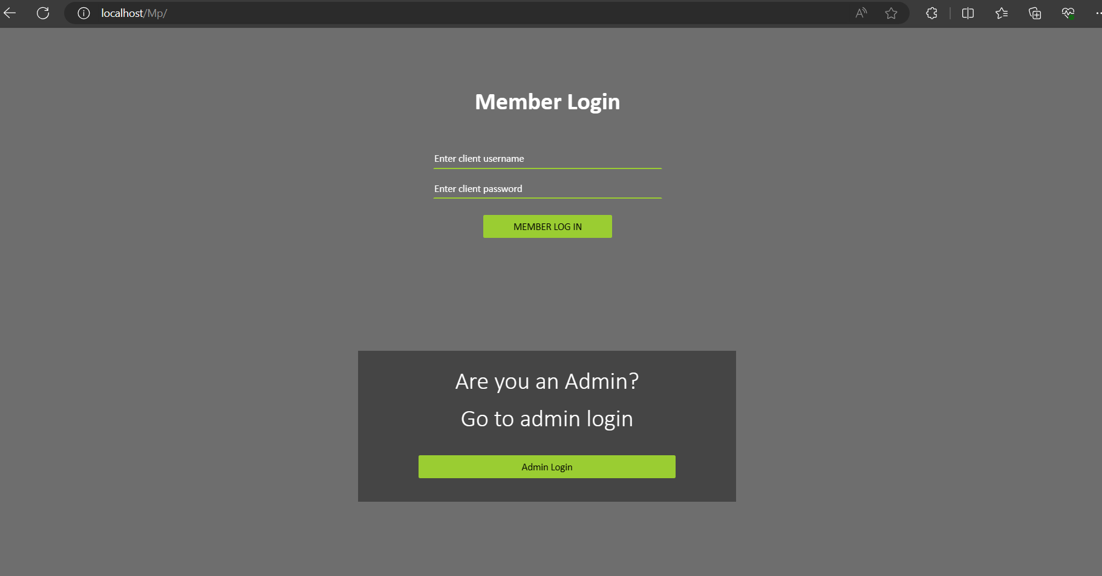

*Fig 1*

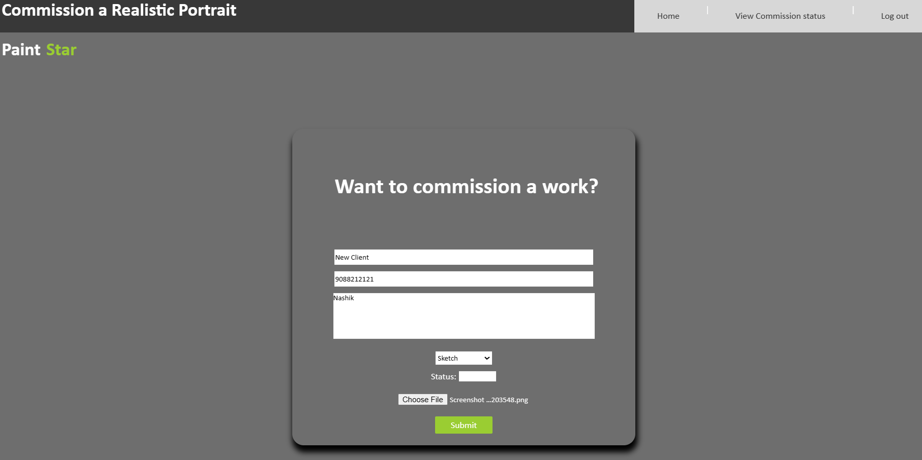

*Fig 2*

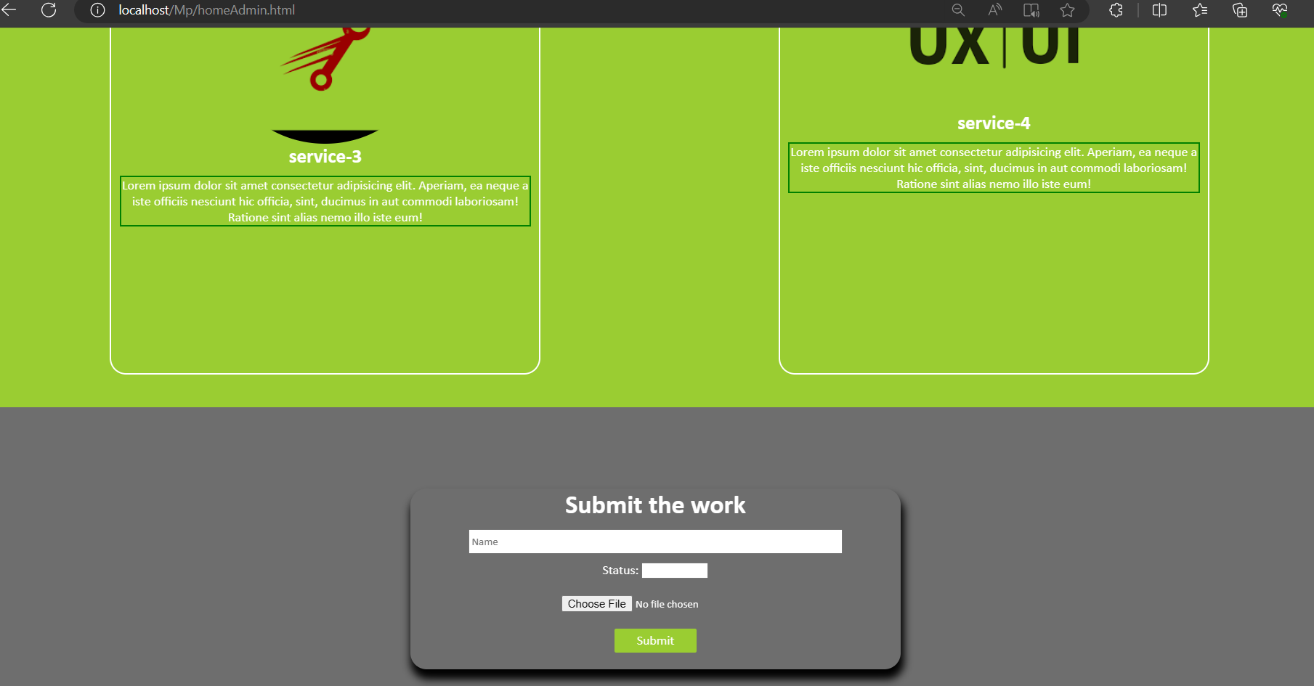

*Fig 3*

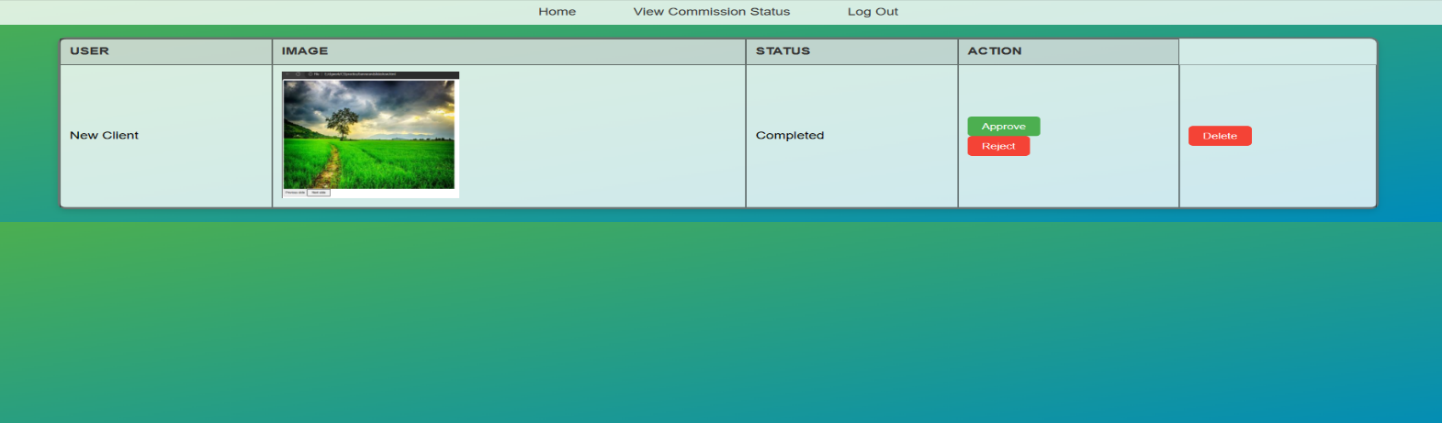

*Fig 4*

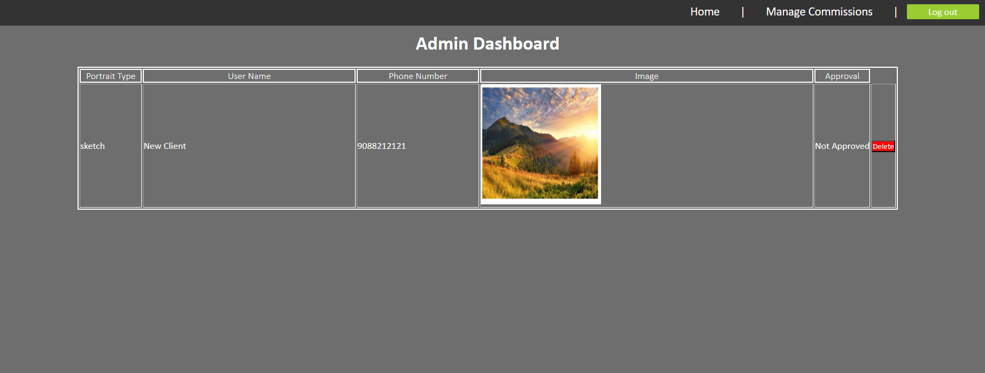

*Fig 5*

**9.0 Skill Developed / Learning outcome of this Micro-Project:**

1. Group work
2. Team Sprit
3. Learnt technologies like PHP, HTML and CSS

**10.0 Applications of Micro Project:**

**1.** Artistic Community Platforms

**2.** Educational Platforms

**3.** Marketplace Integration

**11.0 Name of Group Members:**

|  |  |  |  |  |
| --- | --- | --- | --- | --- |
| Enrolment | Roll No. | Seat No. | Name of Students | Student Signature |
| 2100780182 | 38 | 400545 | Kapil Amolsing Pardeshi |  |
| 2100780183 | 39 | 400546 | Sejal Prakash Pathak |  |
| 2100780202 | 51 | 400559 | Aditya Manoj Surywanshi |  |

Date: / / Evaluated by: Dated Signature of Guide: __________________ Name of Guide: Mr. P. S. Chavan